# PRG455 Project Documentation

## User Manual: How to Use the Application

This application is a simulation of a ticket reservation system. The first form will ask you to enter information about a chosen event. You can change events with the next and previous buttons next to the event title. Once you have entered the information for the event, press the **buy ticket** button. This will open another form that will ask you to enter your personal information, making sure to follow the correct format, to buy a ticket to the event. Enter your personal information in the text boxes and press the **purchase** button. This will open another form that will display the receipt showing event details and personal information.

## Sample I/O

Form 1:

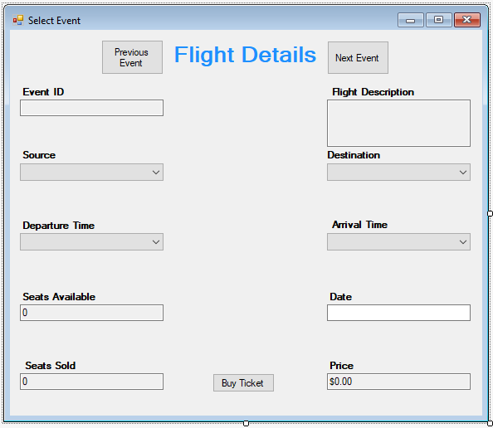

Form 2:

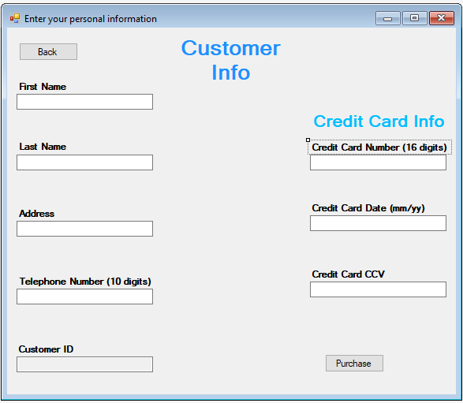

Form 3:

